Experiment No - 01
===============================================================================
Author Name : Vinni Fengade
Roll No. : 67
Sem & Sec : 7th Sem - CSE [B]
===============================================================================
Aim : Demonstrate implementation of Para-Virtualization using Oracle Virtual
Box and Guest OS.
Execution :
===============================================================================
Ubuntu OS
===============================================================================
Step1:
Open Oracle virtual box manager and click create new -> virtual machine.
Step 2:
Provide a name for the virtual machine and select the hard disk size for the virtual machine. Select the storage size as Dynamically allocated memory size and click OK. The virtual machine will be created.

Step 3:
Select the iso file of the virtual OS Ubuntu and click Start.
Step 4:
The virtual OS Ubuntu is opened successfully. Now type the command to open text editor in Ubuntu.

Step 5:Type your desired C program in text editor and save it with the extension (.c).
Step 6:
Type the necessary commands to compile and run the C program.
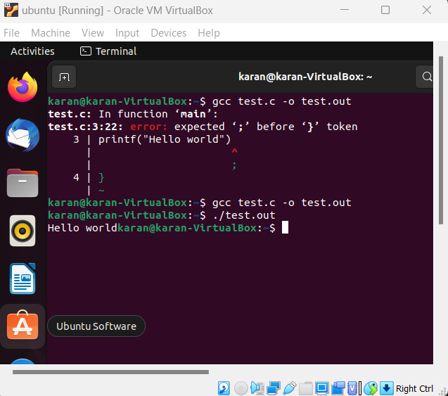

RESULT:
Thus the procedure to run different virtual machines on a single system using Oracle Virtual Box is studied and implemented successfully.

Windows Os
Step1:
Open Oracle virtual box manager and click create new -> virtual machine.

Step 2:
Provide a name for the virtual machine and select the hard disk size for the virtual machine. Select the storage size as Dynamically allocated memory size and click OK. The virtual machine will be created.

Step 3:
Select the ISO file of the virtual OS windows and click Start.
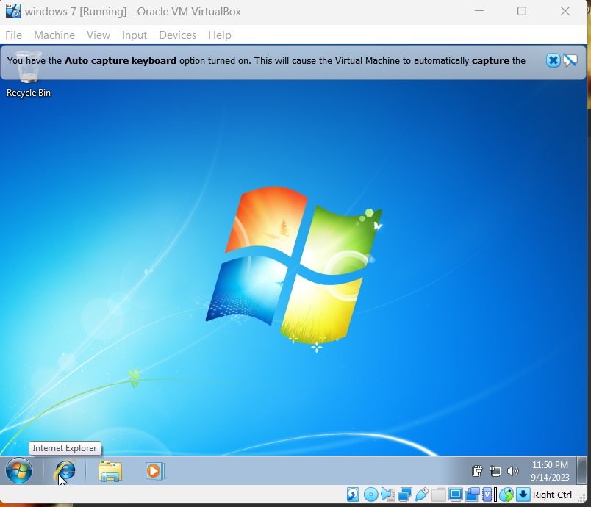

Step 4:
The virtual OS windows is opened successfully. Now type the command to open notepad in windows/install vs code and run a c program.
